LAB 5: Modeling a Hydraulic Piston & Load

Course Number | MENG 3020
Course Title | System Modeling & Simulation
Semester/Year | Fall 2025

Lab/Tutorial Report No. | Lab 5
Report Title | Modeling a Hydraulic Piston & Load
Section No. | 0NA
Group No. | N/A
Submission Date | November 10th, 2025
Due Date | November 9th, 2025

Student Name | Signature* | Total Mark
Michaël McCorkell |  | / 50

* By signing above, you attest that you have contributed to this submission and confirm that all work you have contributed to this submission is your work. Any suspicion of copying or plagiarism in this work will result in an investigation of Academic Misconduct and may result in a ZERO on the work or possibly more severe penalties.
https://academic-regulations.humber.ca/2021-2022/17.0-ACADEMIC-MISCONDUCT

LAB 5 Grading Sheet

Student First Name:  Michaël | Student Last Name:  McCorkell
Part A1: Modeling of Hydraulic Subsystem |  | /10
Part A2: Modeling of Mechanical Subsystem |  | /5
Part A3: Setting the Parameters Values |  | /5
Part A4: Running the Simulation |  | /10
Post Lab Assignment |  | /15
General Formatting: Clarity, Writing style, Grammar, Spelling, Layout of the report |  | /5
Total Mark |  | /50

LAB 5: Modeling a Hydraulic Piston & Load

OBJECTIVES
- To utilize Simscape to construct model of hydraulic systems.
- To understand the modeling of multi-field systems including the mechanical subsystem and hydraulic subsystem.
- To explore how to embed the model parameters in Simulink file and call them as the initial parameters.

INTRODUCTION
In the first part of this lab, you will learn how to utilize Simscape to construct models of hydraulic systems. Figure 1 shows a double-acting piston and cylinder. The device moves the load mass $m$ in response to the pressure sources $p_{1}$ and $p_{2}$. Assume the fluid is incompressible, the resistances are linear, and the piston mass is included in $m$.
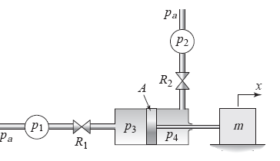
Figure 1: Double-acting piston and cylinder

The system under consideration and the corresponding Simscape model are shown in Figure 2. Note that, similar to the physical system, the system model is composed of hydraulic and mechanical subsystems coupled by the piston.

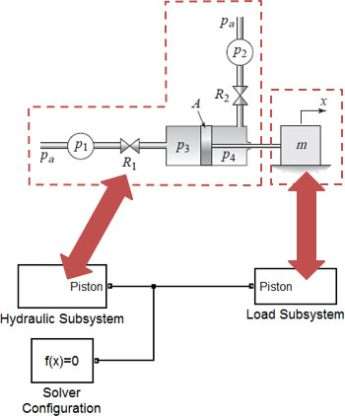
Figure 2: Subsystems of the physical system

In the following steps, we will first build the hydraulic subsystem followed by the mechanical subsystem. Then, we will assemble these to form the complete system model.
A.1 Modeling of Hydraulic Subsystem
- Modeling the Left-Hand Side of the Piston: Open a new Simulink model page. Select and place the following elements and components from the Simulink Library Browser.
- Simscape > Foundation Library > Hydraulic > Hydraulic Sources > Hydraulic Pressure Source
This block represents an ideal source that maintains the pressure difference specified at input port S between physical ports P and T, regardless of the flow. The block has no parameters. Here this block represents the pressure source $p_{1}$ at the left side of the cylinder. This is the pressure above atmospheric pressure.
- Simscape > Foundation Library > Hydraulic > Hydraulic Elements > Hydraulic Reference
The pressure at physical port T of the Hydraulic Pressure Source block is set to atmospheric pressure by connecting Port T to a Hydraulic Reference block. The block has no parameters.
- Simscape > Foundation Library > Hydraulic > Hydraulic Elements > Linear Hydraulic Resistance
This component represents a hydraulic resistance whose pressure drop $p$ is directly proportional to its volumetric flow rate $q_{v}$, such that $p \text{=} Rq_{v}$. The positive direction is from port A to port B. The block has one parameter, the resistance $R$, whose units are selectable. Enter the Resistance variable name $R1$. Here this block represents the resistance of the inlet on the left side of the cylinder.
- Simscape > Foundation Library > Hydraulic > Hydraulic Elements > Hydraulic Piston Chamber
This block represents the fluid volume within the cylinder on the left side of the piston. Enter the following variable names and values shown in the Block Parameters dialog box.
Piston area = A m², Piston initial position = 0 m, Chamber dead volume = 1e-4 m³
Chamber orientation = Positive displacement increases volume, Specific heat ratio = 1.4,
It is important to note that we have selected “Increases at positive” from the Chamber orientation drop-down menu, as opposed to “Decreases at positive.” This indicates that piston motion in a positive direction will increase the volume of the chamber.
- Simscape > Foundation Library > Hydraulic > Hydraulic Utilities > Custom Hydraulic Fluid
This component enables the properties of the fluid used to be modeled. Enter the following variable names and values shown in the Block Parameters dialog box.
Fluid density = 850 kg/m³, Kinematic viscosity = 18e-6, Bulk modulus = 0.8e+9, Relative air trapped = 0
- Arrange and connect the blocks as shown below. This is the left-hand hydraulic network from source $p_{1}$ to piston chamber $p_{3}$.

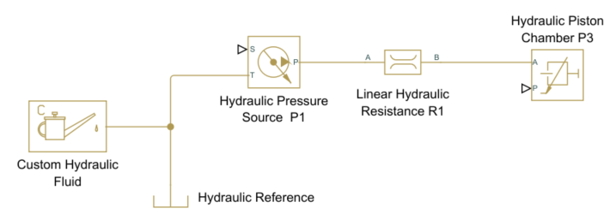

- Now we will add two blocks to the model to define the profile for the pressure source $p_{1}$.
- Select and place the Pulse Generator block from the Simulink > Sources library. Open the Block Parameters dialog box and set the following parameters:
Amplitude = p1, Period = Period, Pulse Width = Width, Phase delay = 0
This parameterization will enable us to easily consider different pressure profiles.
- Next select and place the Simulink-PS Converter block from the Simscape > Utilities library.
Open the Block Parameters dialog box and set Input signal unit = Pa.
- Connect the elements as shown below. This completes the description of the left-hand hydraulic network from source $p_{1}$ to piston chamber $p_{3}$.

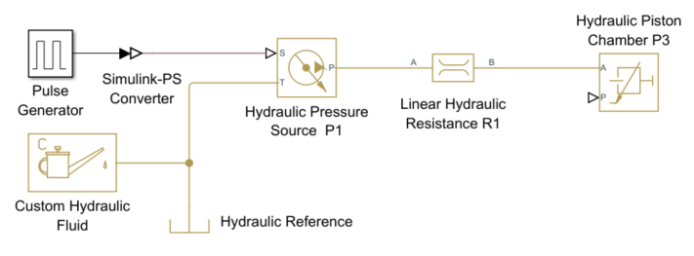
- Modeling the Right-Hand Side of the Piston: Now we must describe the hydraulic piston chamber on the right-hand side of the piston. Using the same six types of blocks previously discussed, place and connect them as shown below. You can copy and paste the blocks inserted earlier.
- Set the new Pulse Generator block parameters as below,
Amplitude = p2, Period = Period, Pulse Width = Width, Phase delay = Delay
The phase delay between the pressure inputs will enable the hydraulic system to drive the load back and forth.
- In the new Hydraulic Resistance block, set the Resistance variable from to R2.
- In the new Hydraulic Piston Chamber block, set the values as below,
Piston area = A m², Piston initial position = 0 m, Chamber dead volume = 1e-4 m³
Chamber orientation = Positive displacement increases volume, Specific heat ratio = 1.4,


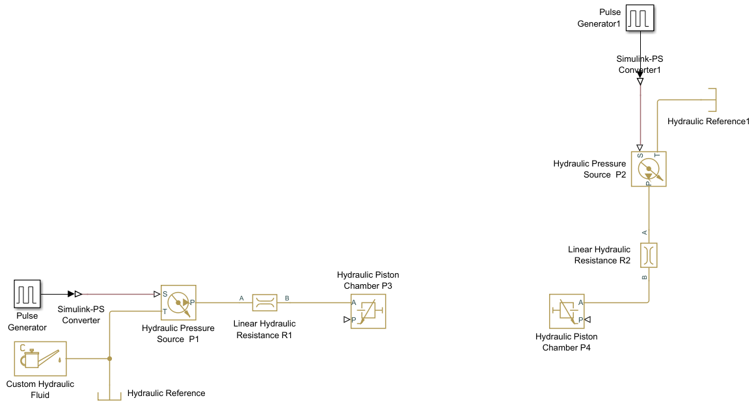
- Converting the Hydraulic Power to Mechanical Power: The hydraulic piston chambers determine the pressure on the left-hand and right-hand sides of the piston, $p_{3}$ and $p_{4}$, respectively. The pressure difference will exert a net force on the piston and drive the load mass.
$$F\text{=}m\overset{¨}{x}→\left(p_{3}\text{-}p_{4}\right)A\text{=}m\overset{¨}{x}$$
Thus, we must introduce elements to capture this conversion from hydraulic to mechanical power.
- Select and insert two Translational Hydro-Mechanical Converter and Mechanical Translational Reference blocks from the following library,
- Simscape > Foundation Library > Mechanical > Translational Elements > Mechanical Translational Reference
- Simscape > Foundation Library > Hydraulic > Hydraulic Elements > Translational Hydro-Mechanical Converter
This block essentially converts a fluid volume change $∆V$on one side of the piston into the resulting displacement of the piston $∆x$, and also converts the pressure $p$ on one side of the piston into the resulting force $f$ on the piston. The piston area $A$ appears in both relationships:
$$A∆x\text{=}∆V f\text{=}Ap$$
Set the Translational Hydro-Mechanical Converter block parameters of $p_{3}$ the left-hand side as below:
Piston area = A m², Converter orientation = Causes positive displacement
Set the Translational Hydro-Mechanical Converter block parameters of $p_{4}$ the right-hand side as below:
Piston area = A m², Converter orientation = Causes negative displacement
- Connect port A on each Converter to the Hydraulic Piston Chamber blocks from the previous diagram, as shown below,
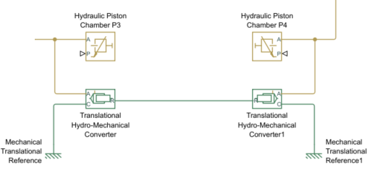

- Next insert a Physical Modeling Connection Port block (PMC_Port) from the Simscape > Utilities library.
- Place and connect it as shown below. Label it as Piston. Thus, the power delivered by the hydraulic system to PMC port 1 represents the net effect of these opposing forces.
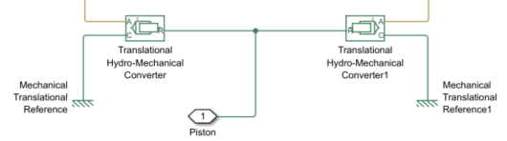
- Open the Block Parameters dialog box of the PMC_port block and set the parameters as shown below to identify its connection to another part of the diagram (the load subsystem in our case):
Port number = 1, Port location = Right
- The size of the piston chambers is controlled by the displacement of the piston. We need to use a sensor to measure the displacement of the piston and provide that information to the Hydraulic Piston Chambers.
- Select and place the Ideal Translational Motion Sensor block and a Mechanical Translational Reference block from the following library:
- Simscape > Foundation Library > Mechanical > Mechanical Sensors > Ideal Translational Motion Sensor
In this block, the C port provides the reference frame. The V output port gives the velocity signal, and the P output port gives the position signal. Set the block parameters as below:
Initial position = 0 m
- Simscape > Foundation Library > Mechanical > Translational Elements > Mechanical Translational Reference
- Connect the P output of the sensor to the P input of each Hydraulic Piston Chamber as shown below,
- Insert a PS-Simulink Converter block from the Simscape > Utilities library and connect it to the V port of the sensor as shown below. This block converts a physical signal (PS) to a unit-less Simulink output signal. Connect the output of this block to a Scope block.
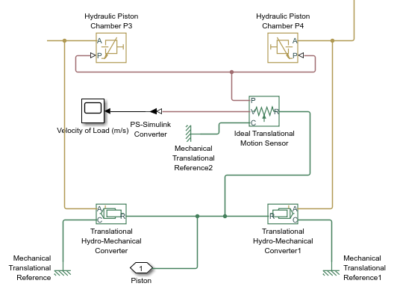
- At this point the model of the hydraulic subsystem should now appear as shown below:

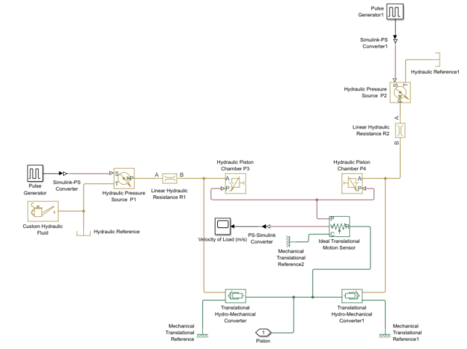

- Provide your final Simscape model diagram of hydraulic subsystem for Part A1 below:

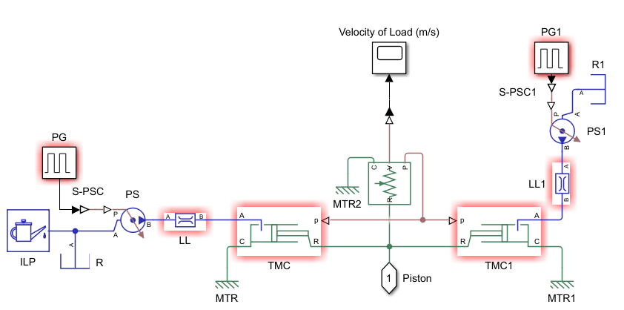

- Creating the Hydraulic Subsystem Block: Because this diagram is getting rather detailed, we will now create a subsystem to represent our model thus far. Use a standard Simulink method to do this. For example, use the mouse to enclose all the elements in a bounding box and then select Create Subsystem from the Edit window.
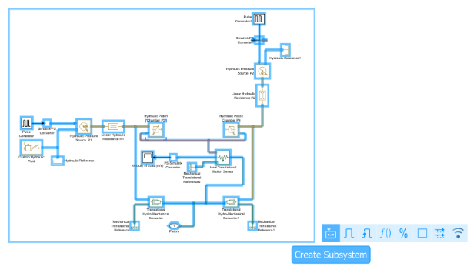

You should see the following model after you change the label to Hydraulic Subsystem and reorient the blocks.
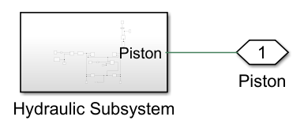
A.2 Modeling of Mechanical Subsystem
Now we are ready to model the purely mechanical part of the system. This consists of the load mass and a spring, which we have added to provide a restoring force on the piston to center it when the pressures are no longer applied. The model of this subsystem is shown below.
- Select and place the following elements and components from the Simulink Library Browser.
- Simscape > Foundation Library > Mechanical > Translational Elements > Mass
Set the Mass block parameters as below:
Mass = m kg, Initial velocity = 0 m/s
- Simscape > Foundation Library > Mechanical > Translational Elements > Translational Spring
Set the Translational Spring block parameters as below:
Spring rate = k N/m, Initial deformation = 0 m
- Simscape > Foundation Library > Mechanical > Translational Elements > Mechanical Translational Reference
- Simscape > Foundation Library > Mechanical > Mechanical Sensors > Translational Motion Sensor
- Simscape > Foundation Library > Mechanical > Mechanical Sensors > Ideal Force Sensor
- Simscape > Utilities > Physical Modeling Connection Port
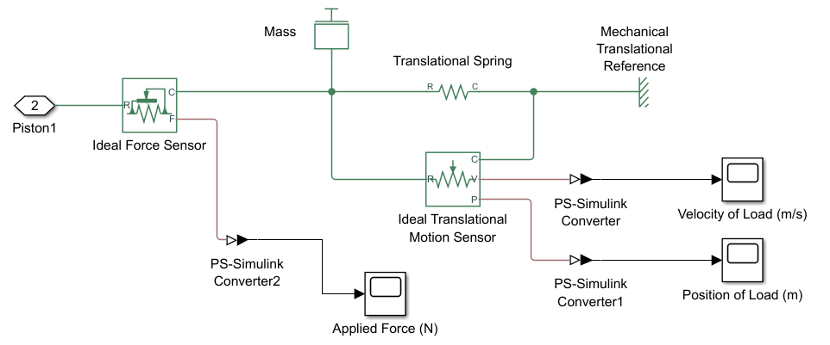
Locate it as shown and label it as Piston.
- Simscape > Utilities > PS-Simulink Converter
- Simulink > Sinks > Scope

- Provide your final Simscape model diagram of mechanical subsystem for Part A2 below:
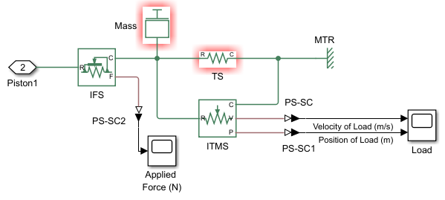

- Creating the Mechanical Subsystem Block: Now create a subsystem model as done previously for the Hydraulic Subsystem. You should see the following model after you change the subsystem block label to Load Subsystem.

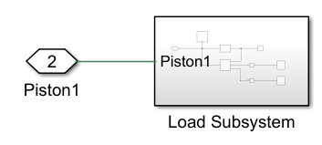
- To assemble the system model, delete the port symbols and connect the input and output ports as shown below. Notice that the port names match. If it is required edit the PMC port connection names inside one of the subsystems.
- Now select and insert a Solver Configuration block from the Simscape > Utilities library and connect it as shown.
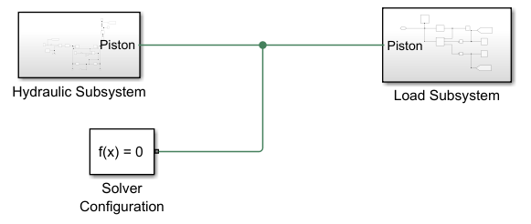

A.3 Setting the Parameters Values
In addition to specifying the Stop Time, to Run the simulation we must specify the numerical values of the various parameters. One way to do this is to assign values to the variables in the MATLAB Command window.
However, if you are going to share the model file, a more convenient way is to store the values in the model file itself. You could do this by typing the values in the Block Parameter dialog boxes, but then you would not have the variables available for use in another program.
To store the values in the model file, you can create a MATLAB script by following the steps below.
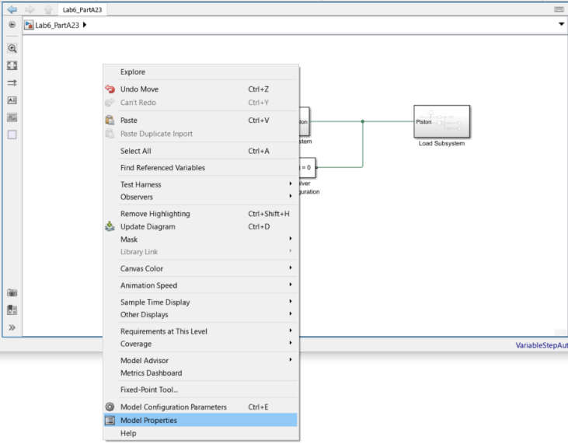
- Right-click in the Simulink model window, select Model Properties from drop down menu. This will bring up the Model Properties dialog box.

- Select the Callbacks tab.
- Select InitFcn from the list of Model callbacks.
- Then, type MATLAB commands into the pane under Model initialization function. Click Ok. These commands will be executed at the start of model simulation. Note that an asterisk will appear next to a callback function that has commands written into it.
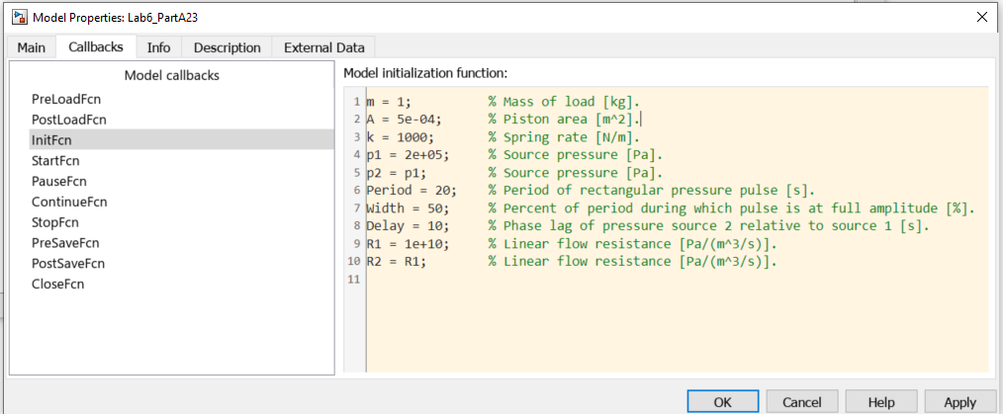
Type MATLAB command here

The Model Parameters:
m = 5; % Mass of load [kg].
A = 5e-04; % Piston area [m^2].
k = 1000; % Spring rate [N/m].
p1 = 2e+05; % Source pressure [Pa].
p2 = p1; % Source pressure [Pa].
Period = 60; % Period of rectangular pressure pulse [s].
Width = 50; % Percent of period during which pulse is at full amplitude [%].
Delay = 30; % Phase lag of pressure source 2 relative to source 1 [s].
R1 = 1e+10; % Linear flow resistance [Pa/(m^3/s)].
R2 = R1; % Linear flow resistance [Pa/(m^3/s)].

A.4 Running the Simulation
- Click on the Model Settings icon in the MODELING tab to open the Configuraton Parameters window, click on the Solver drop down menu and select the ode23t solver. Then click OK.
- Save the model file as Lab6_PartA.slx. Set the Stop Time to 120 seconds and Run the simulation.
- Since we have embedded the Scope blocks in the Load Subsystem, we must double-click on that subsystem to see the Scope. Double click on the Scopes to see the load position and load velocity graphs. Provide the graphs below:
Load Velocity (m/s) Load Position (m) Applied Force (N)

- Measure the maximum displacement of the mass from the initial center position, the maximum speed of the mass and the maximum applied force. Insert the values in Table 1.
Table 1
Maximum Displacement (cm) | Maximum Speed (cm/s) | Maximum Force (N)
10 cm | 4.47 cm/s | 129.5 N

- It can sometimes be helpful to use the signal routing functionalities to simplify the results view.
- Double-click on the Load Subsystem and add the Goto blocks from the Simulink > Signal Routing library as shown below. The Goto block enables a Tag to be placed on a signal and the signal to be received using a From block.
- Set the Goto block parameters for load’s velocity and load’s position as below:
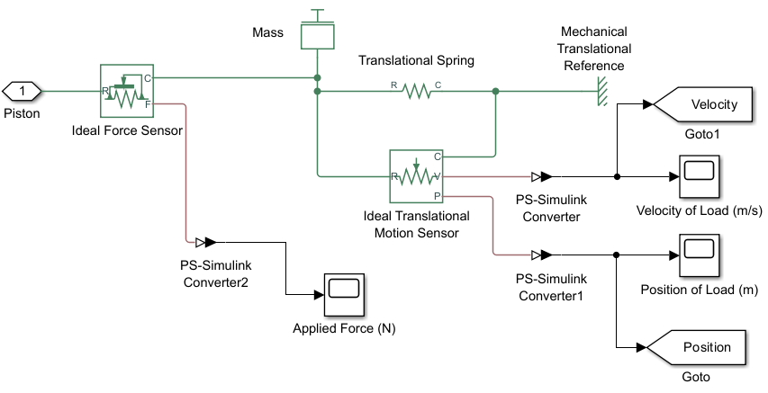
Goto tag = Velocity, Tag visibility = global
Goto tag = Position, Tag visibility = global

- Double-click on the Hydraulic Subsystem and add the Goto blocks from the Simulink > Signal Routing library as shown below. Set the Goto block parameters for each Pulse Generator blocks as below:
Goto tag = Pressure_P1, Tag visibility = global
Goto tag = Pressure_P2, Tag visibility = global

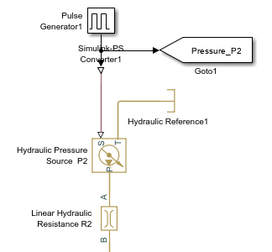
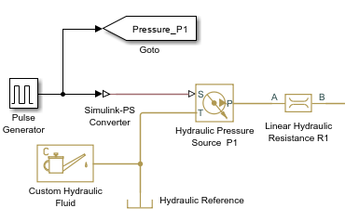

- Return back to the Simulink model main window. Add one Scope block from the Simulink > Sinks library and four From blocks from the Simulink > Signal Routing library and connect them as shown below. The From block enables the Tag from a signal created using a Goto block to be received. Set the From blocks Tags according to the Goto blocks.
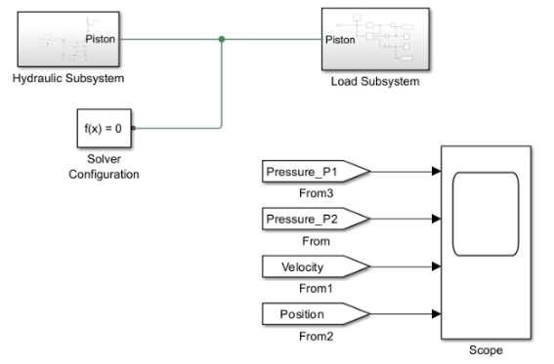

- Run the simulation for 120 seconds. Open the Scope block in the main window. Provide the graph below.

- Briefly explain the operation of system based on the timing sequence of the applied pressures $p_{1}$ and $p_{2}$.
p1 & p2 alternate to control phases in the system's operation, triggering transitions and outputs that follow the applied pressure patterns to maintain a cyclic process of 30 seconds because of the delay applied.

- To see the effect of the restoring spring force we can change the timing sequence of the applied pressures $p_{1}$and $p_{2}$. Open the Model Parameters dialogue window and change the parameter Delay to 10 seconds. In this case the pressure source $p_{2}$ will be activated 10sec after than the pressure source $p_{1}$.
- Run the simulation for 120 seconds. Open the Scope block. Provide the graph below.

- Briefly explain effect of changing the Delay parameter on the system operation. Discuss the effect of the spring and the restoring force to positioning the piston in the center when the pressures are equal or no longer applied.
Changing the Delay parameter affects how quickly the system responds to input changes. Increasing the delay causes the piston to react more slowly to pressure variations, making the system less responsive and potentially sluggish. Decreasing the delay results in a faster response but may lead to instability or oscillations if the delay is too small. The spring provides a restoring force that returns the piston to its central position when the pressures in both chambers are equal or no longer applied. This centering action maintains system stability and prevents piston drift when no net pressure difference exists.

Post Lab Assignment
- Consider the double-acting piston and cylinder system. The device moves the load mass $m$ in response to the pressure sources $p_{1}$ and $p_{2}$. Assume the fluid is incompressible, the resistances are linear, and the piston mass is included in $m$. Suppose that there is a friction between the mass $m$ and the surface with the friction coefficient of $μ$ and a spring, which we have added to provide a restoring force on the piston to center it when the pressures are no longer applied.

Equation of motion of the load mass can be determined as below:
$$m\overset{¨}{x}\left(t\right)\text{+}A^{2}ρ\left(R_{1}\text{+}R_{2}\right)\overset{˙}{x}\left(t\right)\text{+}Kx\left(t\right)\text{+}μmg\text{=}A(p_{1}\text{-}p_{2})$$
where,
Load mass: $m\text{=}5 kg$
Gravity acceleration: $g\text{=}9.81 m\text{/}s^{2}$
Friction coefficient: $μ\text{=}0.6$
Spring coefficient: $K\text{=}1000 N\text{/}m$
Piston area: $A\text{=}5×{10}^{\text{-}4} m^{2}$
Hydraulic resistance: $R_{1}\text{=}R_{2}\text{=}{10}^{10} Pa.s\text{/}m^{3}$
Source pressures: $p_{1}\text{=}p_{2}\text{=}2×{10}^{5} Pa$
Fluid density: $ρ\text{=}1 kg\text{/}m^{3}$

Build the following system using Simulink block diagram model of the system. Set the component values as parameters and assign the values in the Model Properties as shown in Part A3 of the lab manual.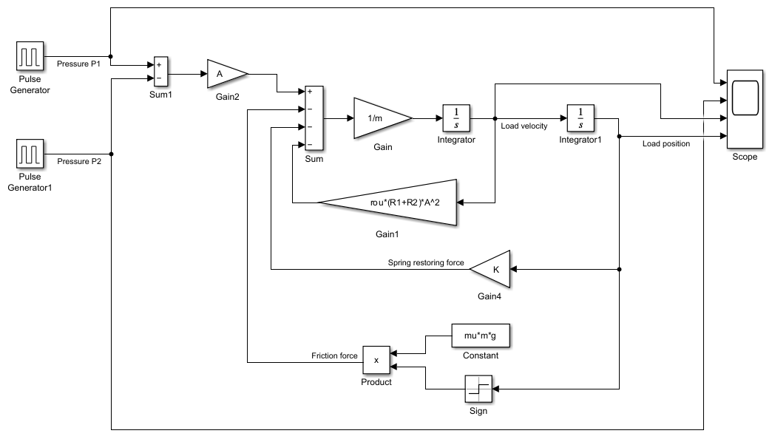
Set the Pulse Generator blocks parameters as shown below:
Pressure P1:
Amplitude = $2×{10}^{5} Pa$, Period = $60 sec$, Pulse Width(%) = $50$, Phase delay = $0$
Pressure P2:
Amplitude = $2×{10}^{5} Pa$, Period = $60 sec$, Pulse Width(%) = $50$, Phase delay = $30 sec$

Run the simulation for 120 seconds and provide the following components:

  - The Simulink model of the system and the Simulink .slx file.
  - Explain how the Friction force has been generated and the reason for having the Sign block.
  - Plot the Pressure P1, Pressure P2, Load velocity and Load position as separate graphs in a single Scope with white background and appropriate titles. Provide the graphs.
  - Determine the maximum speed and maximum displacement of the mass from the center point.
  - Decrease the friction coefficient $μ$ to zero which results to have a frictionless surface. Run the simulation and plot the new graphs. Provide the graphs.
  - Determine the maximum speed and maximum displacement of the mass from the center point in this case and explain the effect of having no friction in the maximum displacement.

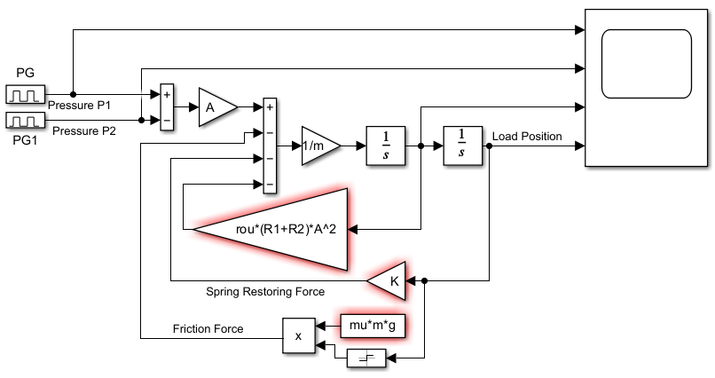
B) In Simulink, the friction force is calculated by multiplying the friction coefficient by the gravitational force, which yields a constant number. The Sign block uses velocity to calculate the friction direction, which might be +1, -1, or zero. This indicates that the friction force opposes the motion, acting positively in one direction and negatively in the other. The Sign block is required to accurately simulate kinetic friction, which constantly resists the direction of motion.

D)
Max Velocity = 4 cm/s
Max Displacement = 7.5 cm

F)
Max Velocity = 4 cm/s
Max Displacement = 10 cm
When there is no friction, the piston experiences no restrictive force to oppose its motion. As a result, for the same applied pressure, the piston can reach a higher velocity (4 cm/s) and achieve a greater maximum displacement (10 cm) compared to a system with friction. The absence of friction means that none of the input energy is lost as heat, so more of it is converted into kinetic and potential energy of the piston. This allows the piston to move further and possibly oscillate around the equilibrium position before settling.

